# Salesforce – Financial Services Products > Collections & Recovery

<https://www.salesforce.com/financial-services/debt-collection-software/>

Debt collection software provides the real-time engagement channels and case management tools to manage collection cases.

## Einstein Prediction Builder

Using the power of data and AI, Einstein can detect and flag inconsistencies in payment behavior that may suggest a borrower is likely to miss one or more payments. These insights can trigger alerts to bankers or advisors, or automatically notify the borrower about upcoming or slightly overdue payments. And it does it all with the intent to encourage timely payments and prevent accounts from being marked overdue and routed to collections for recovery efforts.

## Pre-collections Automated Outreach

Create a series of omnichannel communications to help bring borrowers' accounts current before they are routed to collections. **Pre-collections outreach journeys** can be customized for various loan and account types. Using **templates and automated drip campaigns** you can ensure borrowers receive personalized communications tailored to their unique situations, without requiring your service team to craft and send emails on a case-by-case basis.

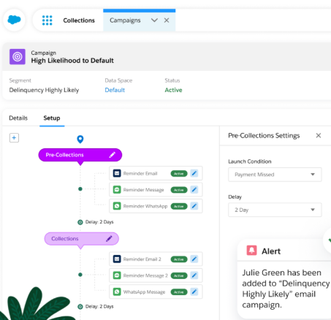

## Collection Agent Console

Equip your collections agents with a unified console, giving them a 360-degree customer view of each borrower. AI tools embedded directly within agents' workflow help automate manual tasks and assist collections agents through various processes.

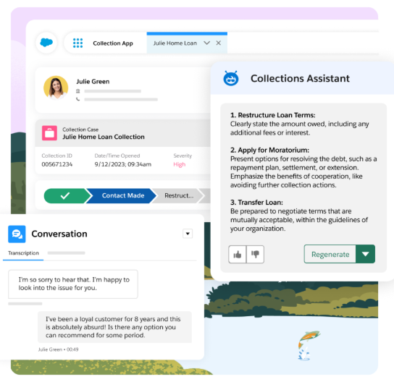

## Collections Process Automation Studio

Use templates and low/no-code tools to build end-to-end collections processes with ease — saving your collections agents time and increasing productivity via a step-by-step process flow to successfully recover funds every time.

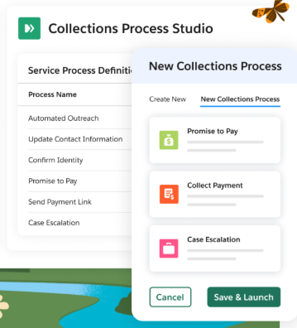

## Promise to Pay

Record and monitor borrowers' promise of payment with customizable promise-to-pay widgets which facilitate tracking, reminders, alerts, and escalations for both borrowers and agents, ensuring timely follow-up and accountability.

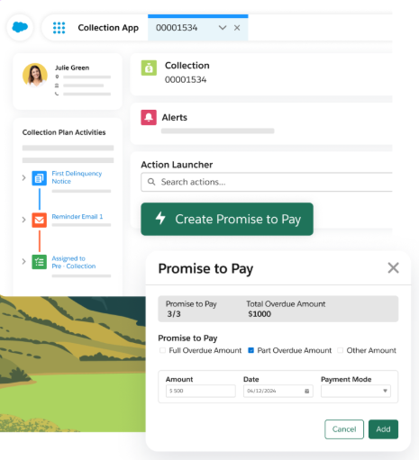

## Real-time Payments

Payment integrations and Salesforce Pay Now allow collections agents to capitalize on the moment a borrower agrees to pay. Agents can send payment links in real-time, allowing them to collect payments and settle delinquent accounts instantly.

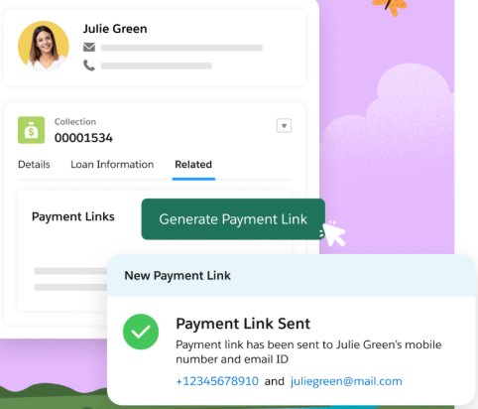

# Cloud Collect - collections management solution

<https://appexchange.salesforce.com/appxListingDetail?listingId=a0N30000001g6zgEAA>

Automate the entire collections activity cycle with triggers and workflows, managing tasks and activities

Escalations, status updates, payment processing, write-off, outside collection agency assignment

Predefined reports and dashboards help track agent and customer performance to better understand customer payment and response to collection actions

* **Create cases with recommended steps to communicate to customers based on their profile.**

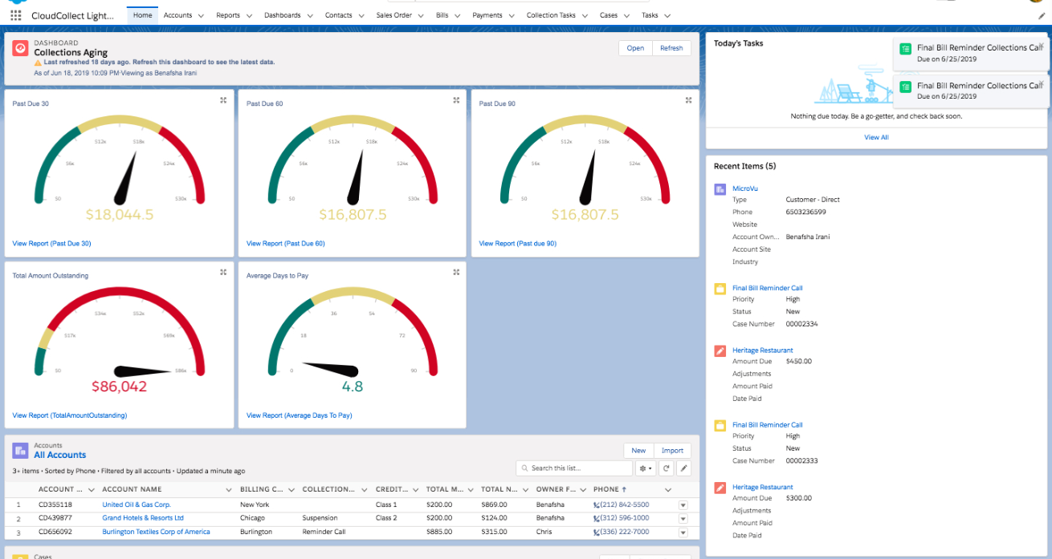

* Personalize interaction with customers – at preferred time / channel

## Account Management

* Call collection tasks:

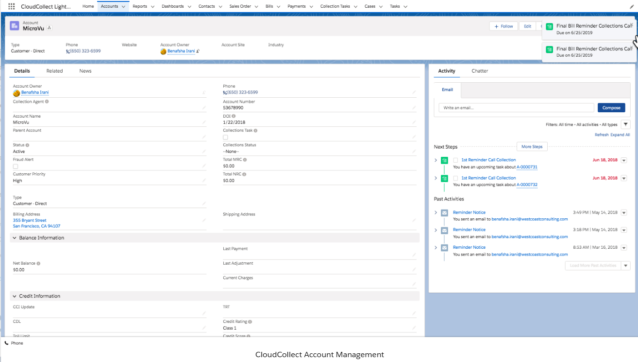

## Phone integration:

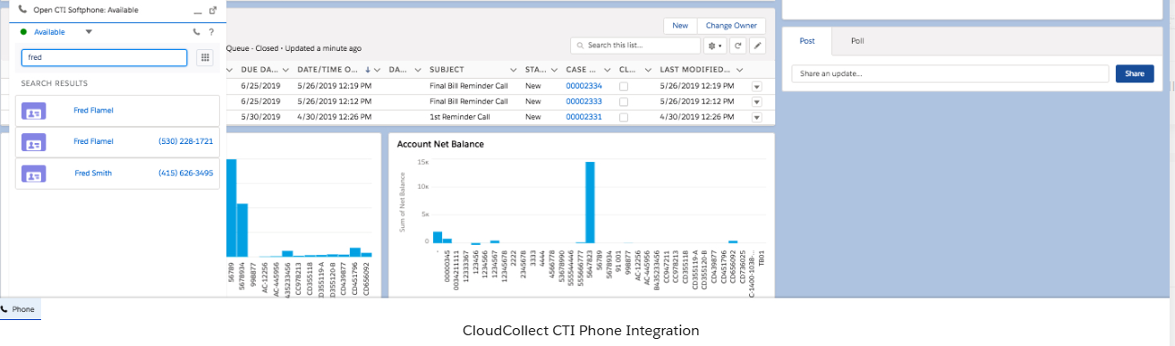

# Crabb – Credit Management System

<https://appexchange.salesforce.com/appxListingDetail?listingId=a0N3A00000DvNtdUAF#:~:text=CRABB%20supports%20the%20credit%20recovery,in%20the%20revenue%20generation%20chain>.

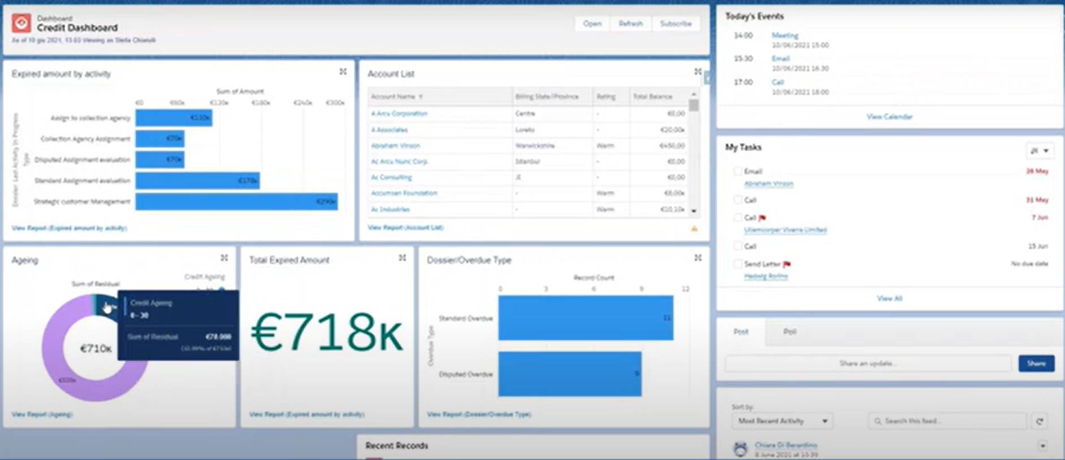

Recovery activity

## Dossier Object

### See file (account) status, any amount due, collections activity

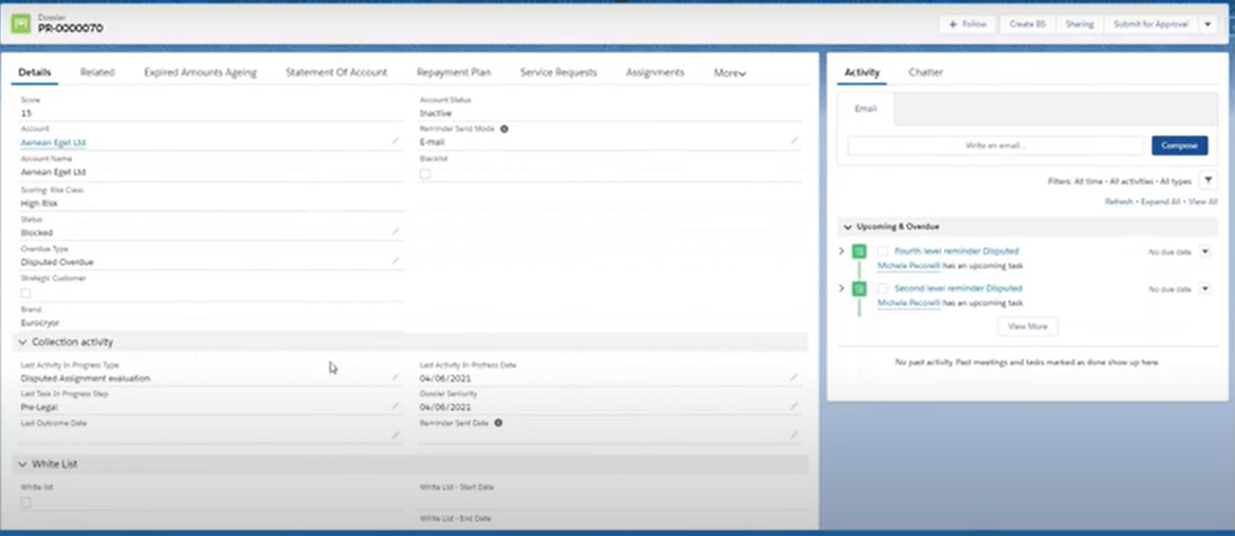

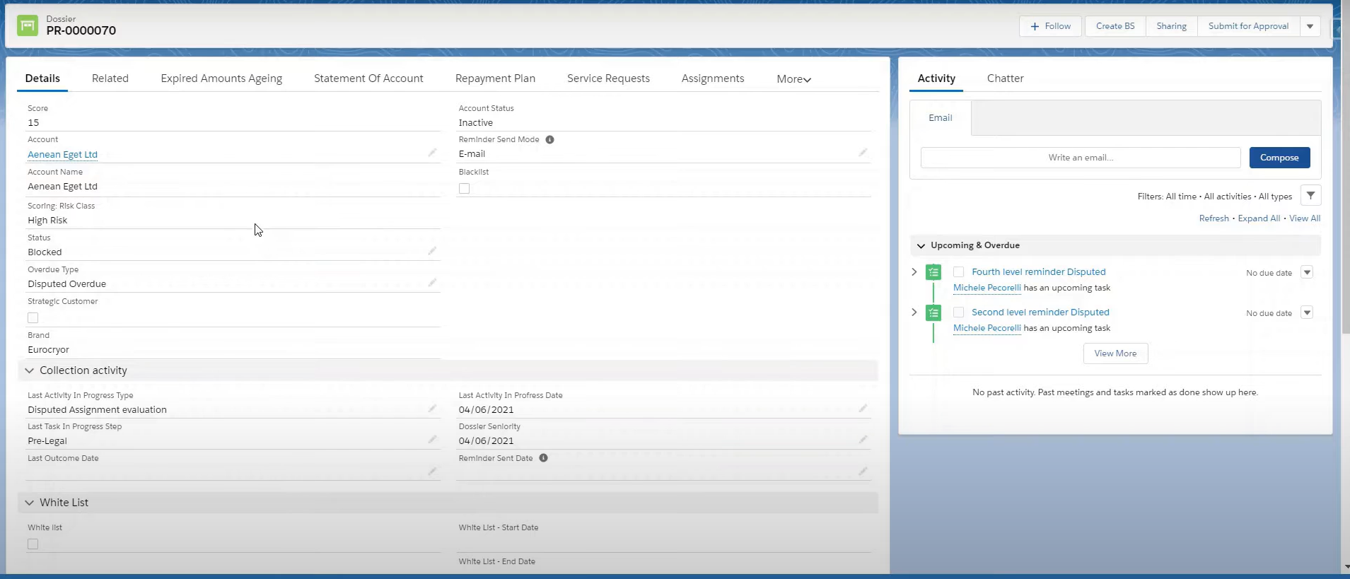

### Ageing dashboard

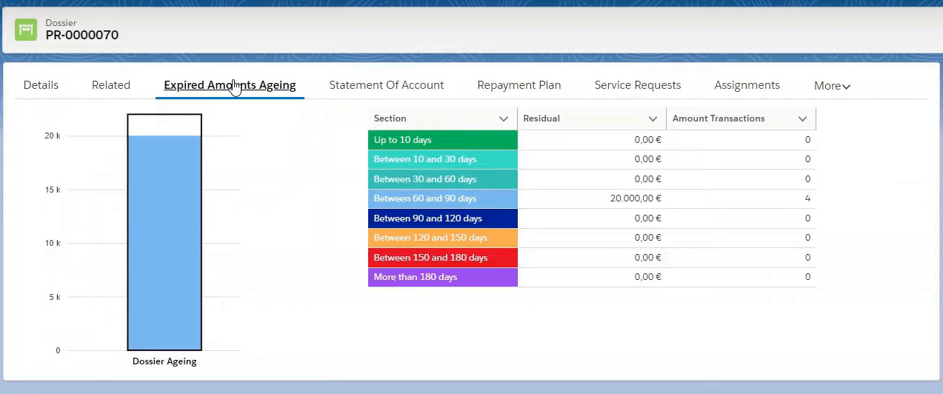

### Customer Statement

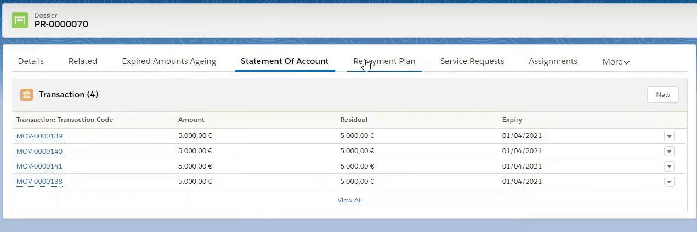

### Create Repayment Plan

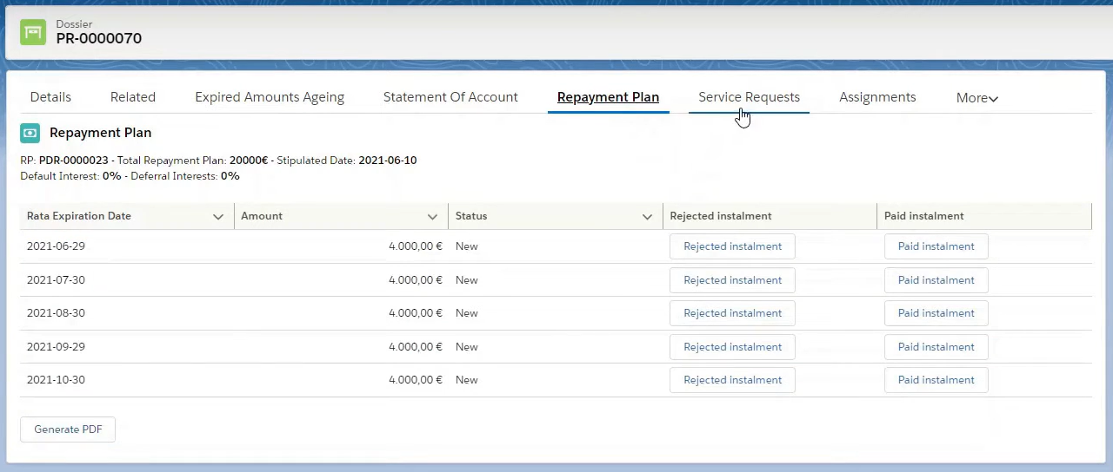

### See All Comms sent to Customer

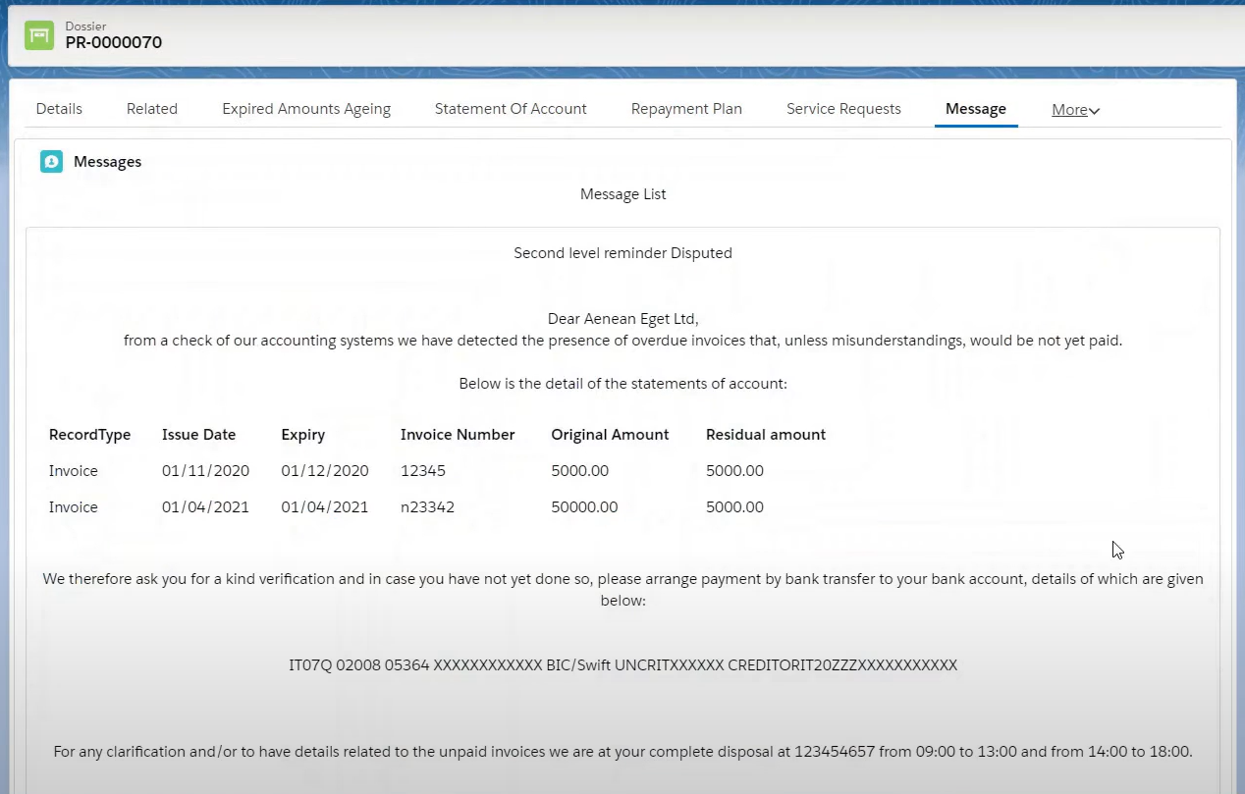

See all tasks performed.

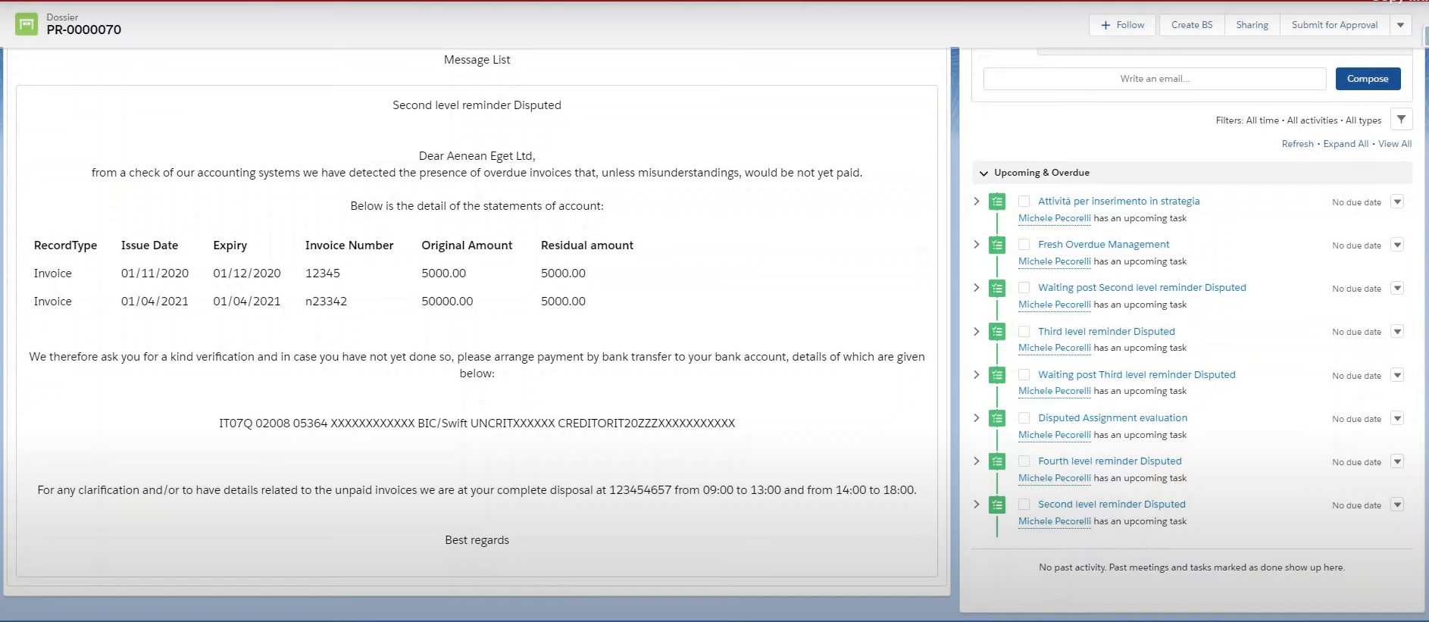

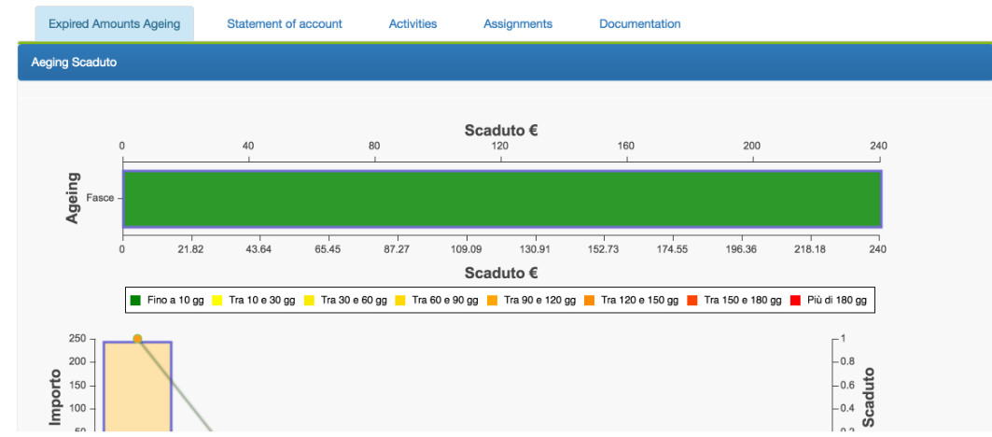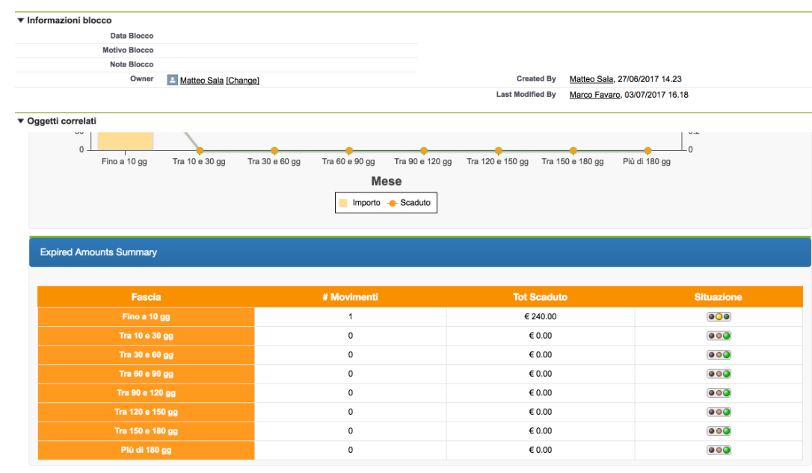

## Collection Strategy Management / Configuration

* System-configured workflow that replicate the credit policy
  + Including reminders : SMS, email

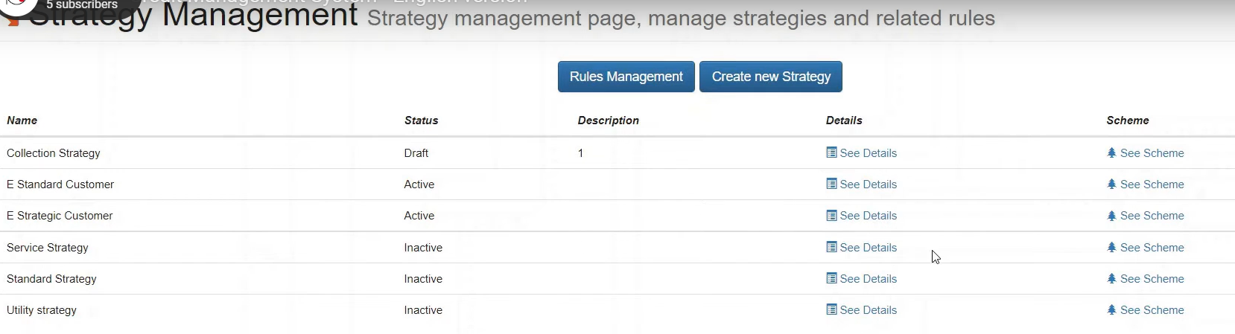

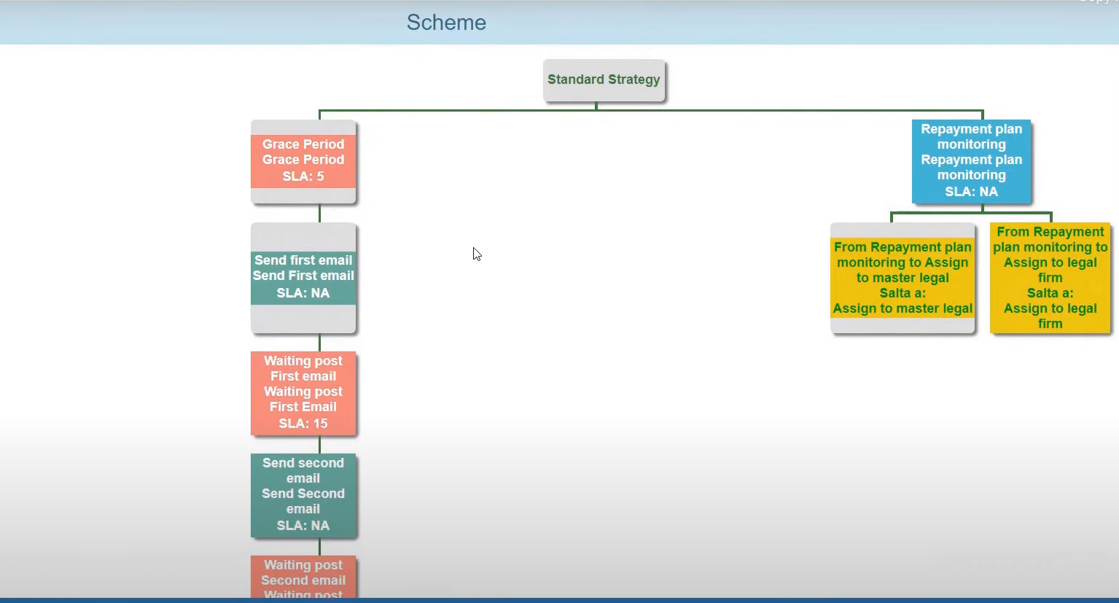

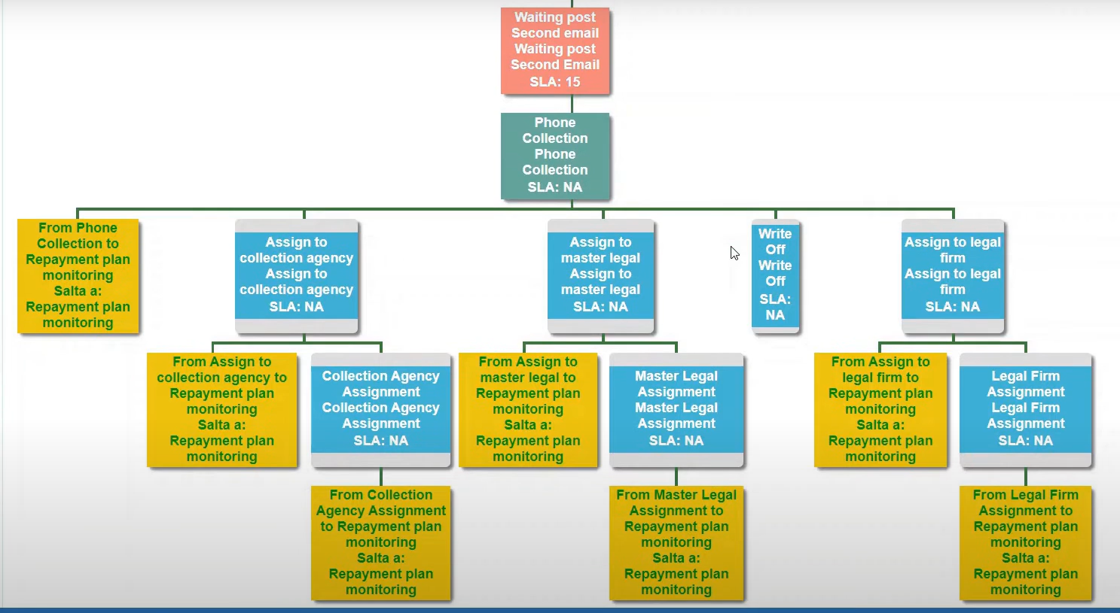

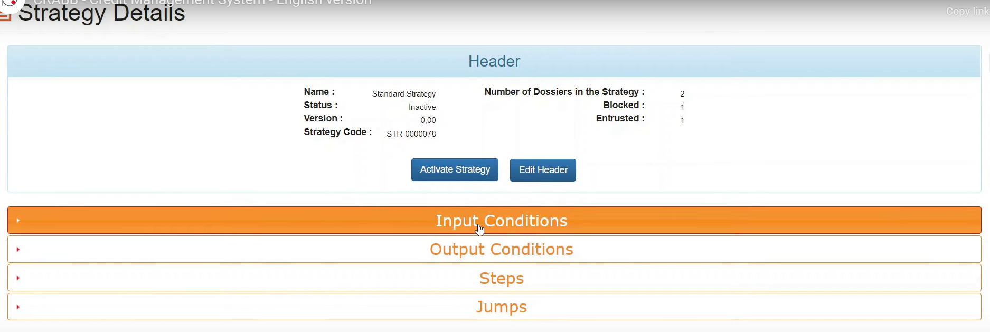

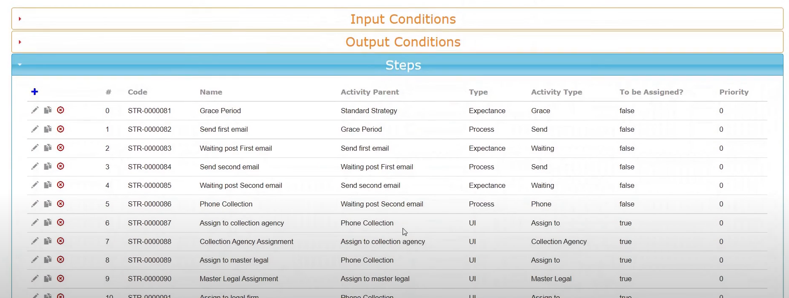

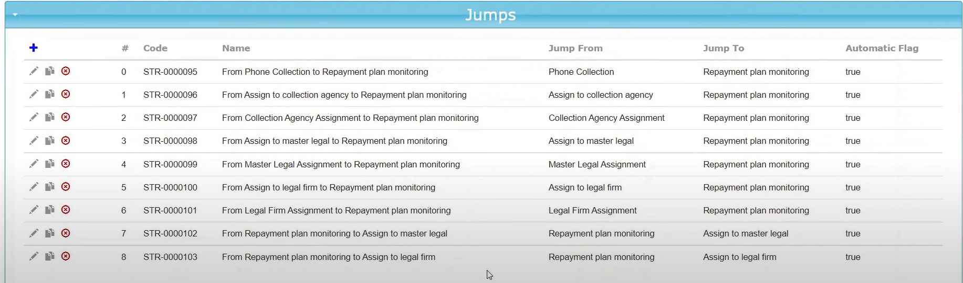

## Manage Lots & Assignments

* Assign to law firm or collection agency
* They can work directly in SF

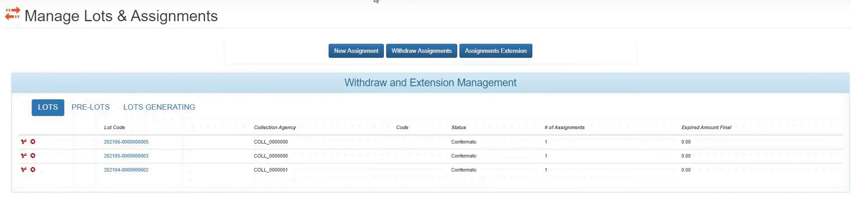

# MaxCredible

<https://appexchange.salesforce.com/appxListingDetail?listingId=a0N3A00000DqChJUAV&tab=d>

## Debtor Card

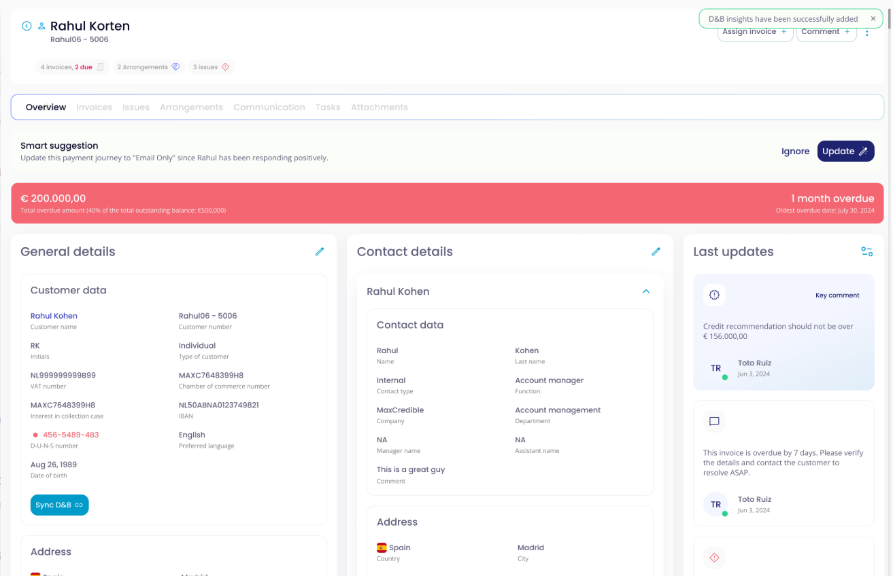

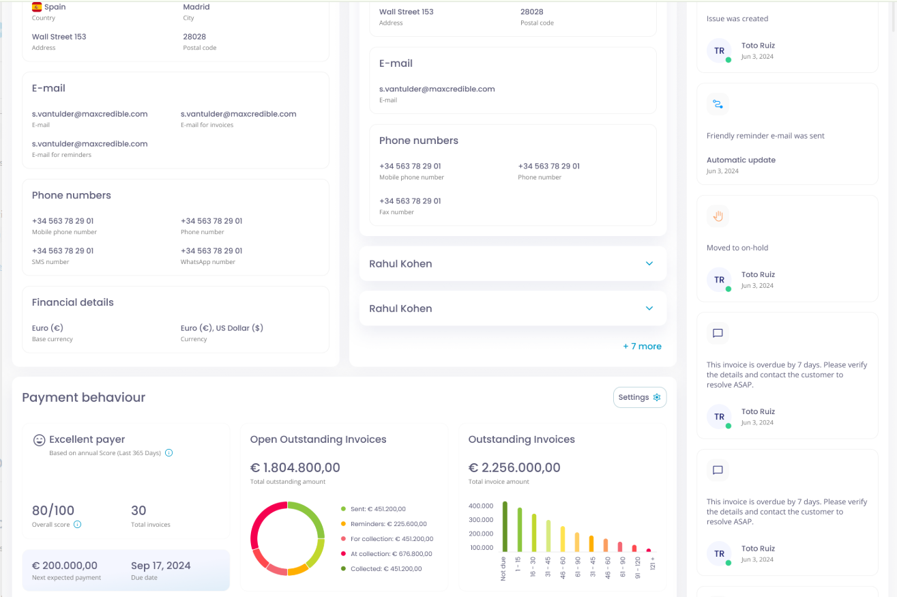

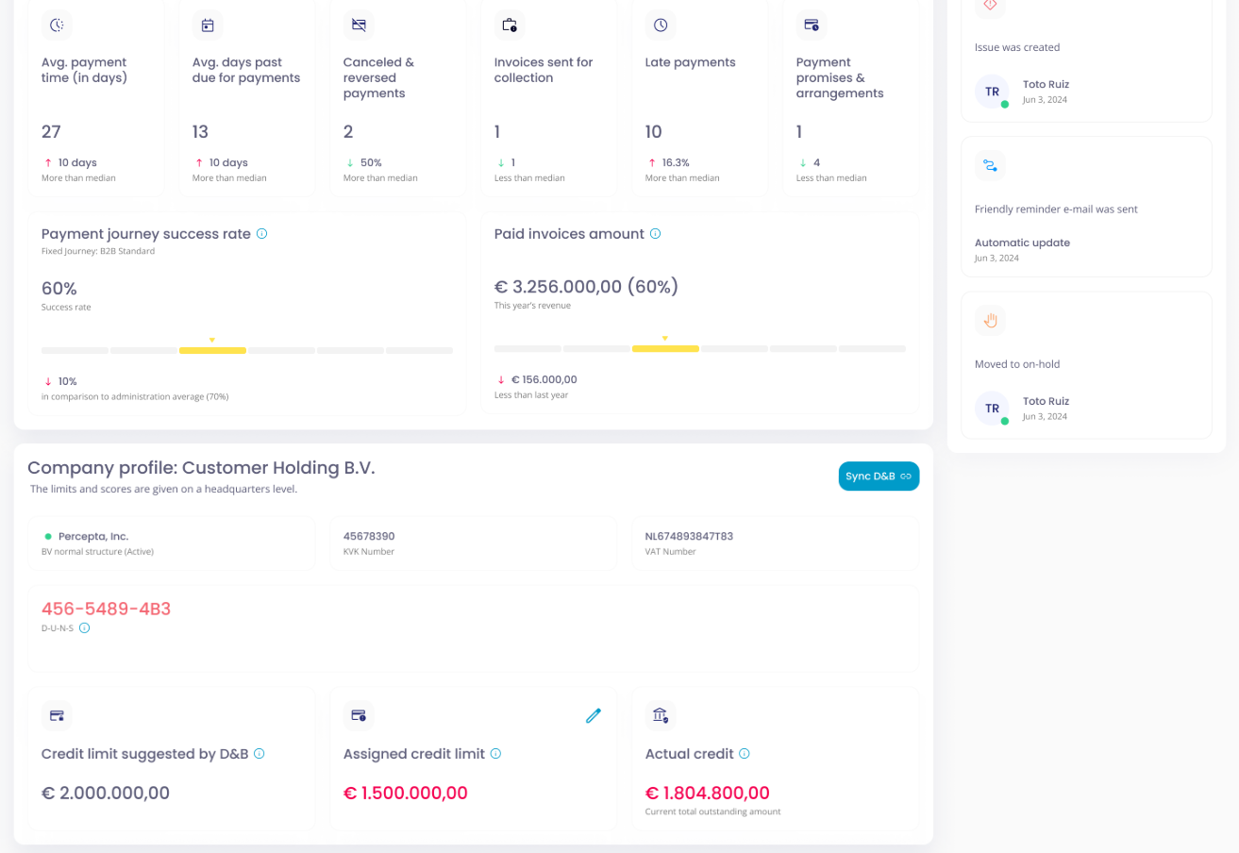

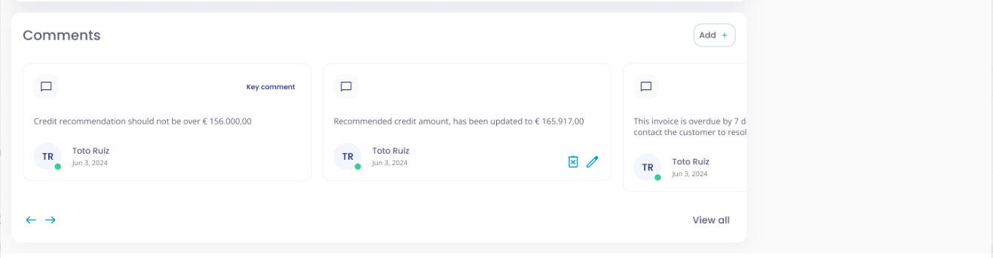

## Payment Journeys

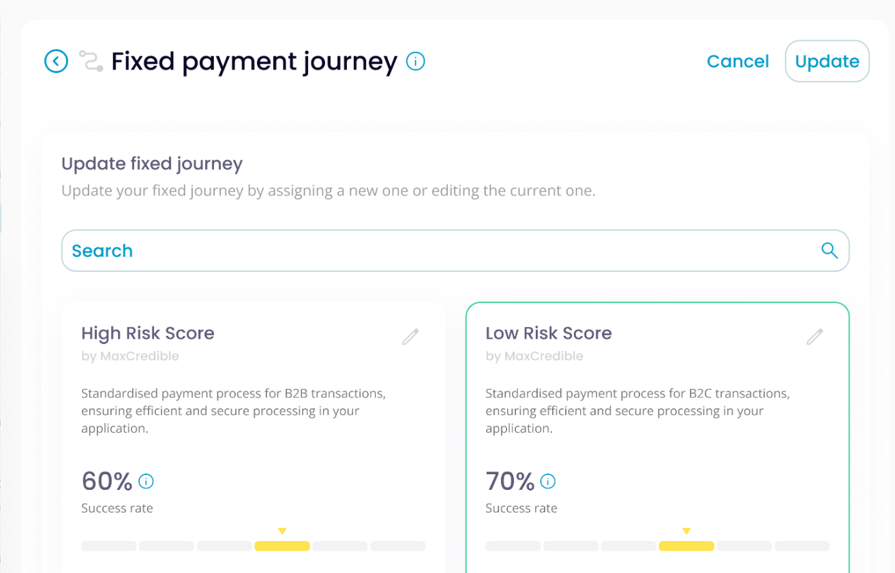 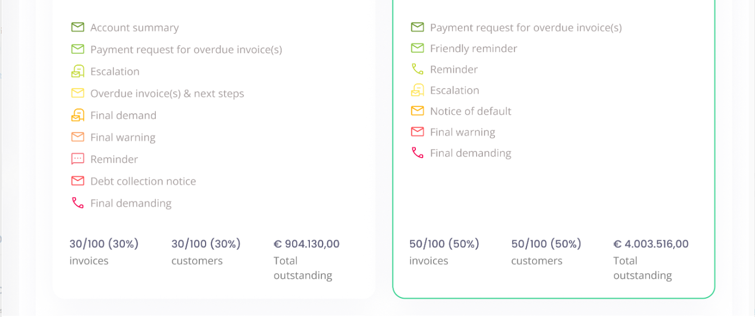

# CollectXpert - Collections

* Rule-based engine, allowing business to customize workflows and collection strategies.

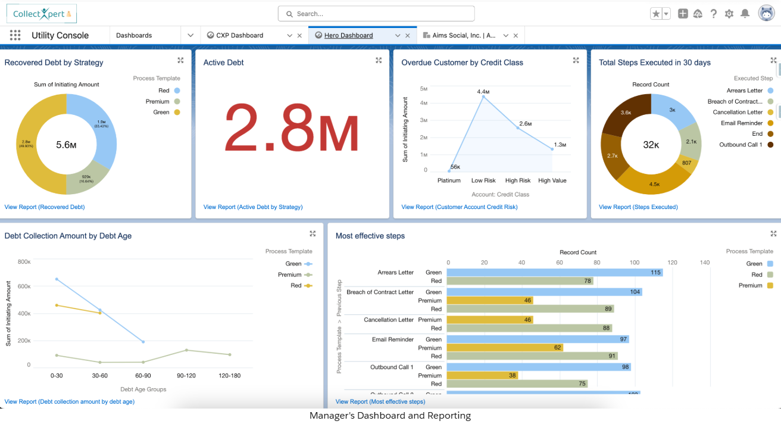

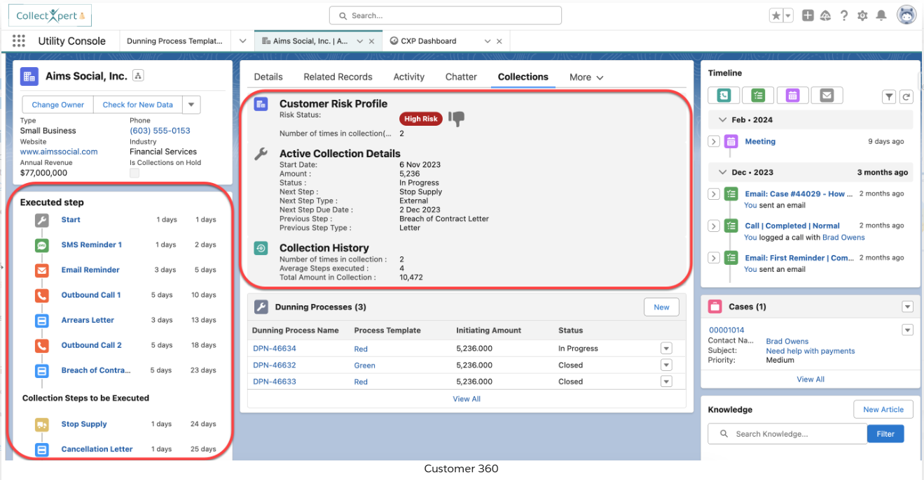

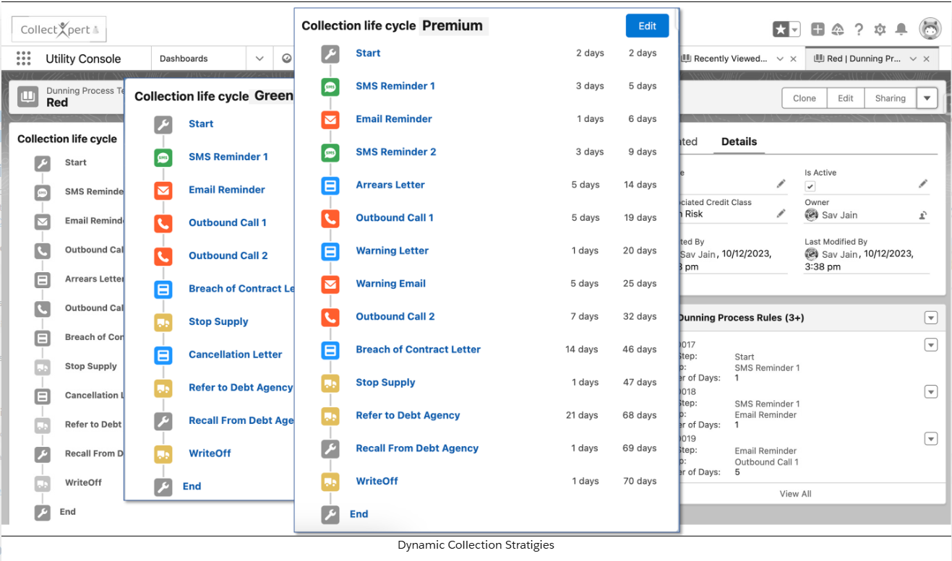

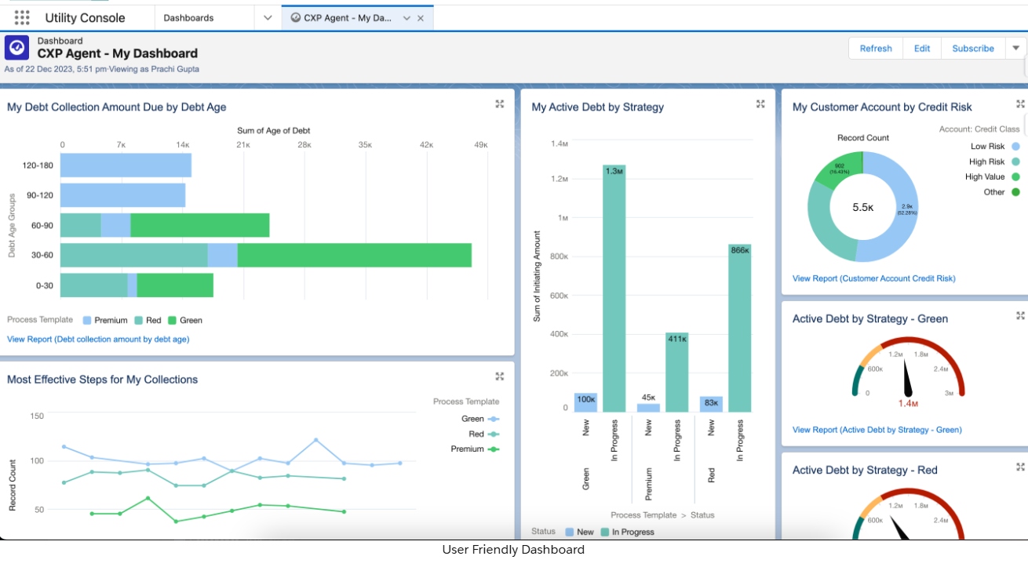

# FinSpectra

## Action Plan

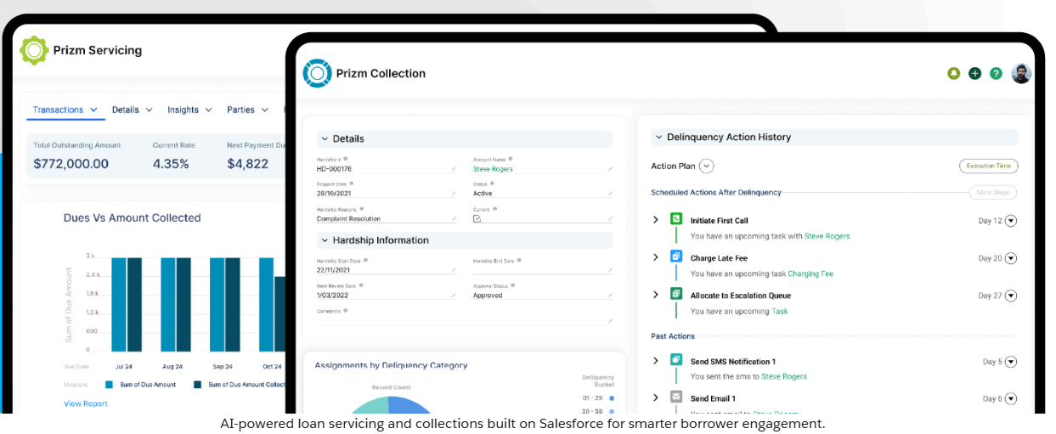

# Review

<https://appexchange.salesforce.com/appxListingDetail?listingId=a0N30000001t593EAA>

<https://www.salesforce.com/financial-services/cloud/>